**Question 1.b. Display the following images: magnitude, phase, non-maximum suppressed, T1, T2 and final edge images. Make sure that you normalize these images to lie between the minimum (0) and maximum color you can display (in most cases equal to 255).**

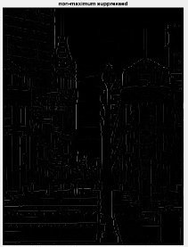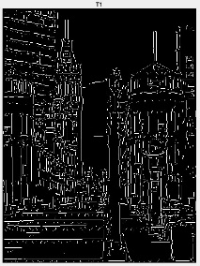 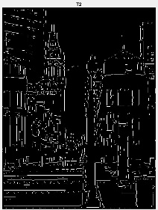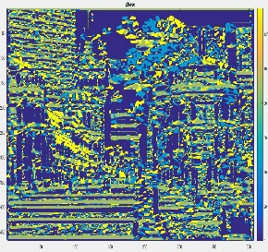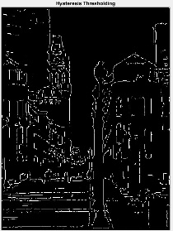

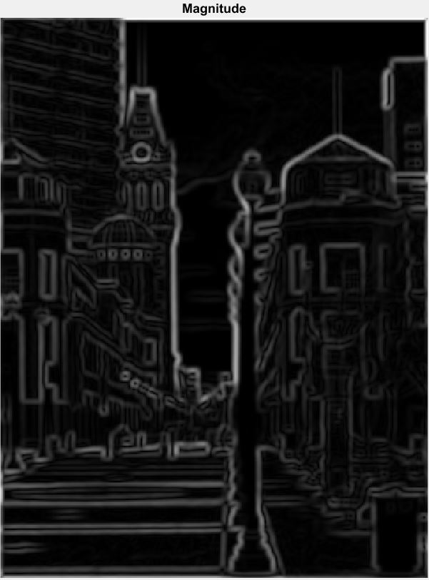

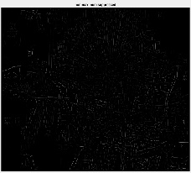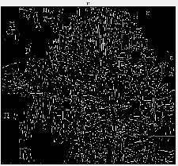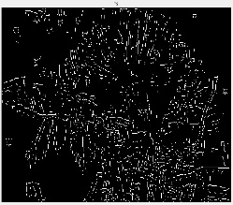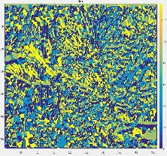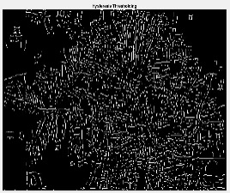

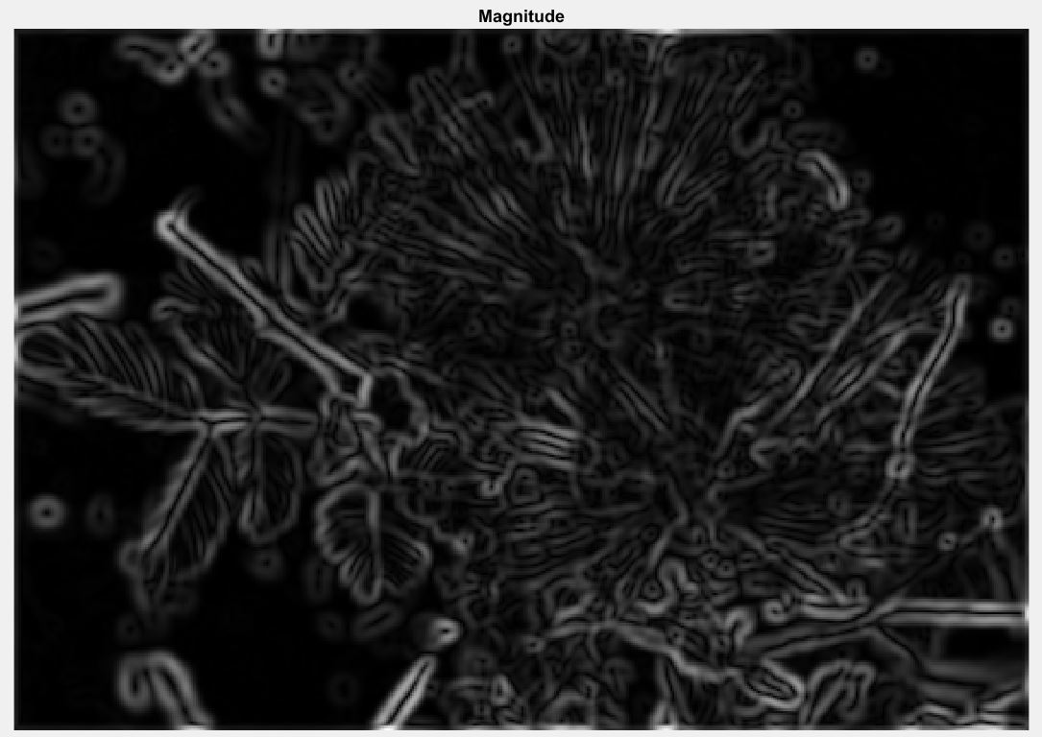

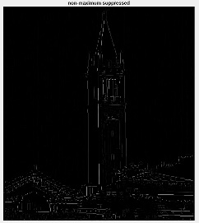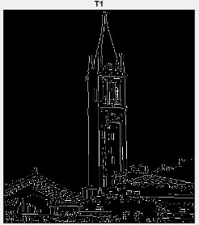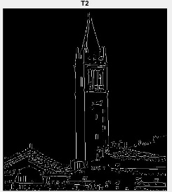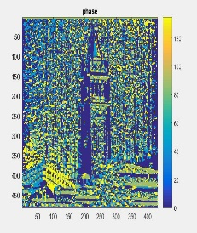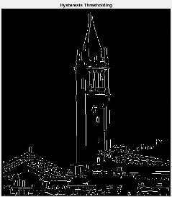

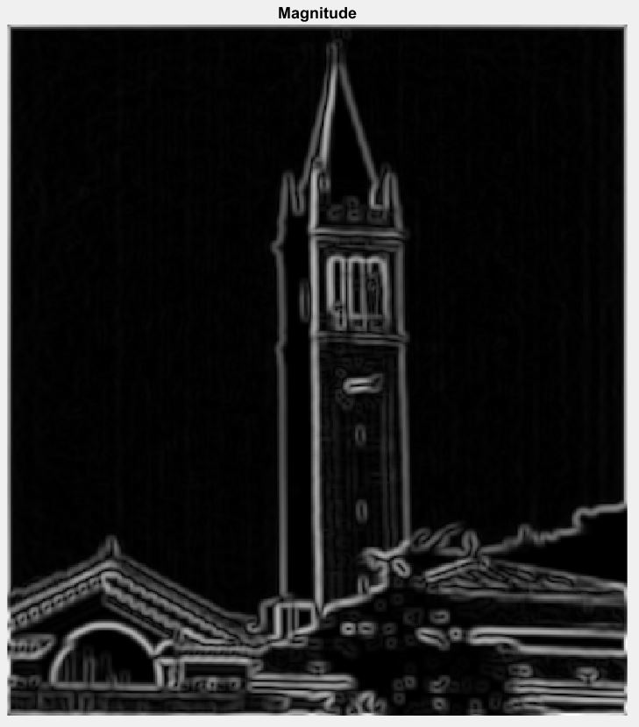

***Please check the folder attached called Picture to see pictures in full size.***

**Question 1.c. Briefly list the major steps involved in implementing the edge detector. Explain how edge linking (the final step of the Canny algorithm) was implemented.**

There are four major steps in the Canny edge detection method. The first step is to use a Gaussian filter to smooth the input image. The gradient of the smoothed array can generate x and y partial derivatives. The second step is to compute the gradient magnitude and orientation using the two partial derivate arrays. Third, using the method of Nonmaxima Suppression to thin the ridges of gradient magnitude. Finally, use the Hysteresis Thresholding algorithm to detect and link edges.

The hysteresis thresholding algorithm takes two thresholds, t1 and t2 (t2=2*t1), to generate two threshold edge images, T1 and T2. T2 will contain fewer false edges, but it may contain gaps in contours due to the higher threshold. When the end of the contour is reached, it looks in T1 at the location of the 8 adjacent entities for edges to link to the contour. It continues to collect edges from T1 until the gap in T2 is filled out. This method resolves the edge linking problem.

**Question 1.d. List the parameters that determine the performance of the algorithm. What parameter values did you use and why?**

There are a few parameters that need to configure in order to generate the best result. Initially, the threshold values need to be carefully selected. If the threshold is too high, then there will not be any values that get plotted on T1 and T2, resulting in a total black output image. If the threshold is too low, then it means there will be too many values that get plotted on T1 and T2, which means some noise is also labeled as the edge. In my case, the ratio of the threshold values is t2=2*t1.

Besides, the filter size and the sigma of the Gaussian filter also need to be tuned. These parameters indicate the spread of the Gaussian filter and control the degree of smoothing. A larger sigma or the larger the filter size, will deliver a more blurred effect. There is a trade-off between smoothing and edge localization. Smoothing the input image will increase the uncertainty to the location of the edge. In other words, a greater sensitivity to the location of the edge will increase the sensitive to the noise at the same time. Therefore, the Gaussian smoothing factors need to be carefully chosen.

Values used: Sigma=2; Filter Size = 5; t1=0.08; t2=0.16;

**Question 2. Discuss the magnitude results obtained in 1.b above by comparing them with a 3x3 and 5x5 Sobel gradient operator applied to each image.**

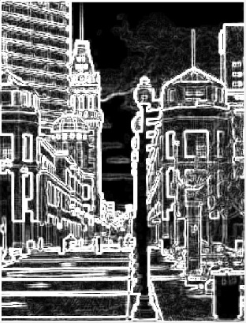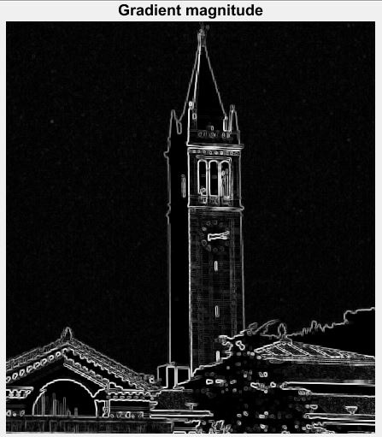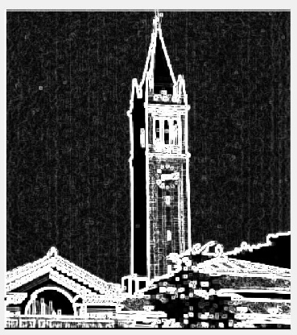

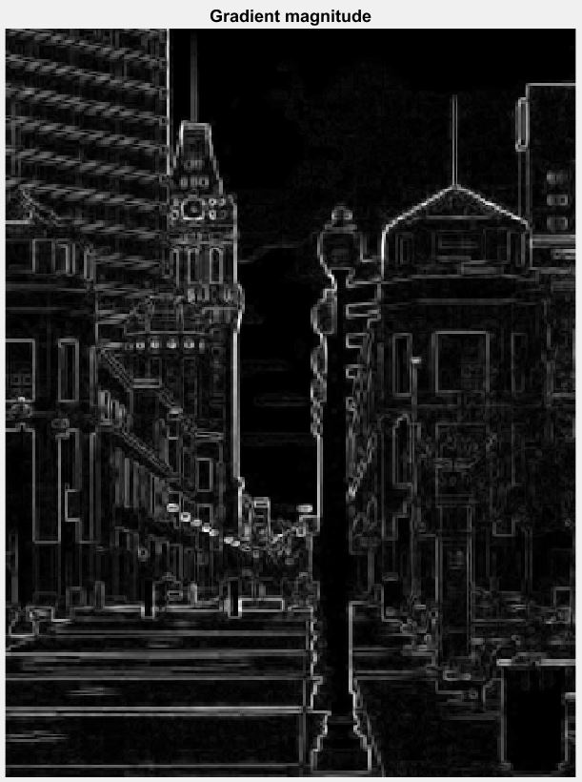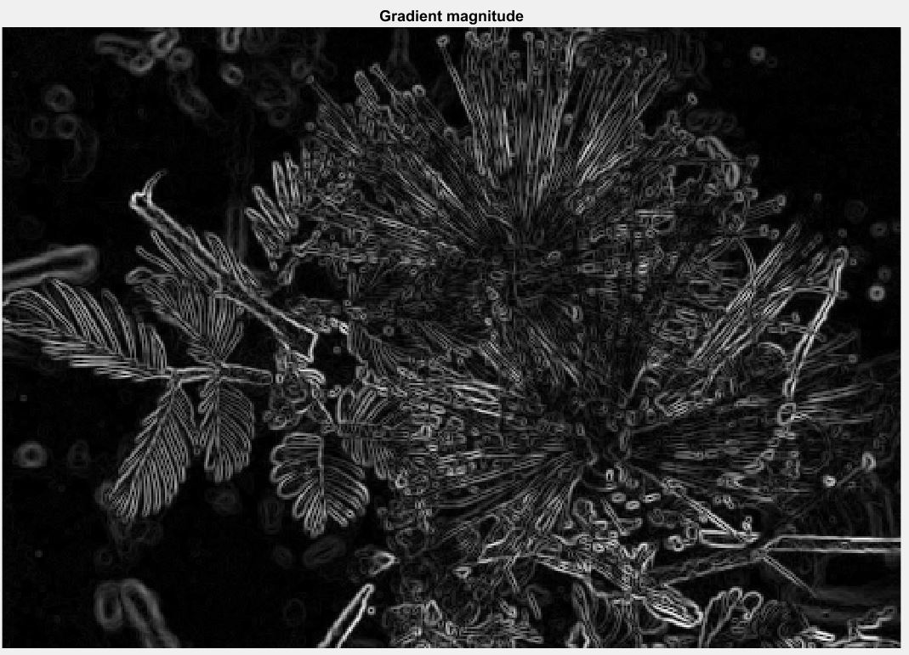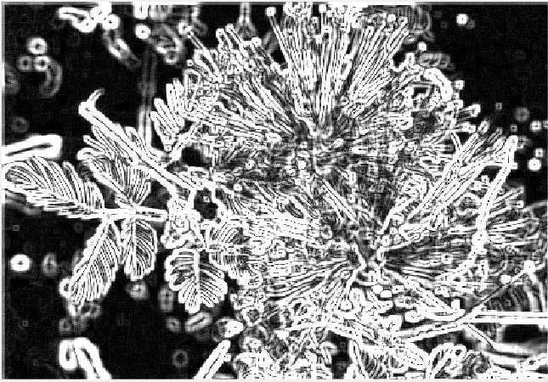

Above are the results from using the filter size of 3*3 and 5*5 Sobel Gradient operator. Unlike the canny edge operator, the Sobel operator does not apply Gaussian filter to remove the noise and the non-maximum suppression to thin edges detected. It just computes the gradient magnitude of each image. Therefore, the Sobel method is very sensitive to the noise. Its detected edges are not as smooth and accurate as those detected by the canny operator.

Reference: Jain, R., Kasturi, R., Schunk, B. G., Machine Vision, McGraw-Hill Inc., first edition, 1995, pp. 168-173.